Slant Rhyme (Near, Half)

🔹 What is Slant Rhyme (Near Rhyme / Half Rhyme / Imperfect Rhyme)
# Source: Chatgpt (GPT-4-turbo) at [8/1/2025]
A slant rhyme is a type of rhyme where the final consonant sounds are similar, but the vowel sounds are different, or vice versa. It creates an approximate or partial sound match, rather than a full one like perfect rhyme.
It’s also called:
- Near rhyme
- Half rhyme
- Imperfect rhyme
- Oblique rhyme
- Off rhyme

🧱 Structural Patterns
# Source: Chatgpt (GPT-4-turbo) at [8/1/2025]
Slant rhymes can take several forms:
- Same final consonants, different vowels
  - Example: cut / mat
- Same vowels, different final consonants
  - Example: time / mine
- Partial sound similarity (especially in stressed syllables)
  - Example: shape / keep

📝 Examples
# Source: Chatgpt (GPT-4-turbo) at [8/1/2025]
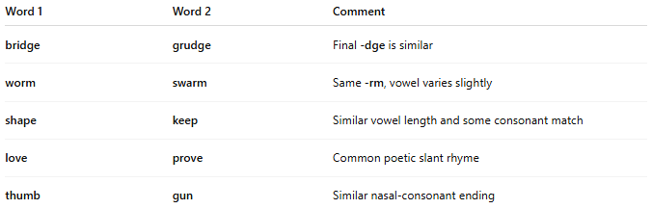
Word 1 | Word 2 | Comment
bridge | grudge | Final -dge is similar
worm | swarm | Same -rm, vowel varies slightly
shape | keep | Similar vowel length and some consonant match
love | prove | Common poetic slant rhyme
thumb | gun | Similar nasal-consonant ending

🎨 Poetic Effect
# Source: Chatgpt (GPT-4-turbo) at [8/1/2025]
Slant rhymes are often used to:
- Create subtle musicality without sounding forced.
- Avoid predictability of perfect rhymes.
- Reflect tension, unease, or ambiguity in tone or meaning.
- Match natural speech more closely than perfect rhymes.

🖋️ Used By
# Source: Chatgpt (GPT-4-turbo) at [8/1/2025]
- Emily Dickinson (a master of slant rhyme)
- W. B. Yeats
- Modernist poets
- Rap and spoken word artists (often mix slant and perfect rhymes)

📘 Comparison
# Source: Chatgpt (GPT-4-turbo) at [8/1/2025]
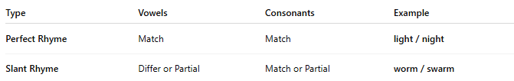
Type | Vowels | Consonants | Example
Perfect Rhyme | Match | Match | light / night
Slant Rhyme | Differ or Partial | Match or Partial | worm / swarm

